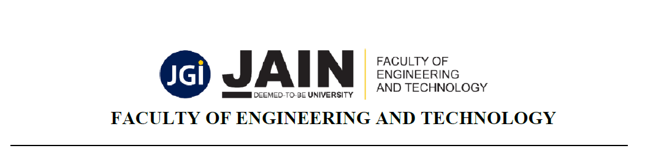
Program: CSE STAR C | Semester: IV
Course Name: WEB TECHNOLOGIES | Course Code: 23CSE404
Submission Date: 12/04/2026 | Year: II
Name: Vishrutha G | USN: 24BTRCT147
LAB EXERCISE 10

10. Implement Sessions and cookies to store information to be used across multiple pages in Exercise-2.
CODE:
login.php (Set Session & Cookie)

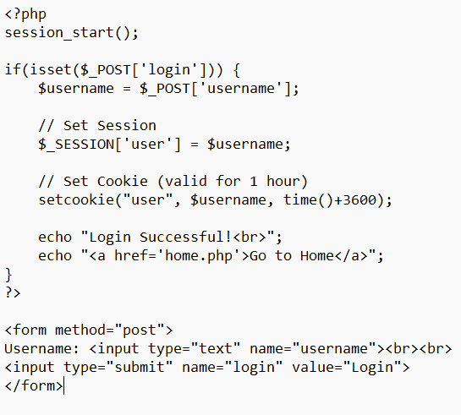

home. php (Use Session & Cookie)

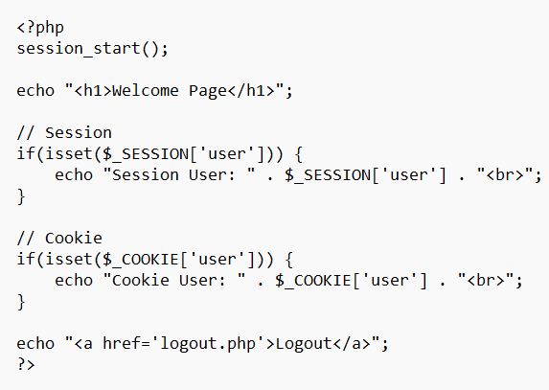

Logout .php (Destroy Session & Cookie)

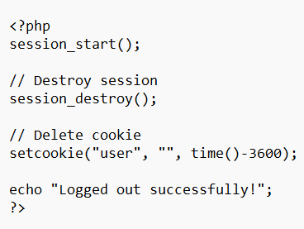

OUTPUT:
